5th October 2021
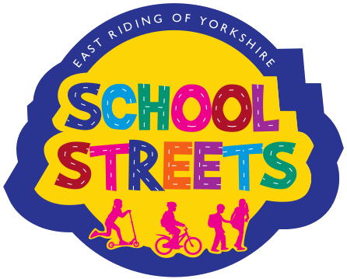

Dear Parent/Carer,

The School Streets initiative is almost at it's first anniversary and, whilst the immediate area outside school is calm, I am fully aware of the concerns further away from the school. Further work needs to be done and the school will work in partnership with ERYC and other agencies to look at this ongoing issue.

In the meantime, and for the purposes of the School Streets agenda promoting a healthy lifestyle, I am delighted to inform you of a reward scheme for any child that walks, cycles or scoots to school and back. This can be direct from home, a reasonable distance from school or from one of the Park and Stride car parks on a regular basis, starting from next week. Regular participants will receive a special gold token each week, worth 5 house points, and will enjoy an in-school treat such as extended bike/scoot and play sessions. The reward scheme will run until Thursday 2nd December as, for the run up to the holidays, our watchful Christmas Elves will return!

If you have any queries at all about School Streets or the reward scheme please contact the school or look on the School Streets website.

Thank you for your support,

Yours sincerely,

Mrs H Whyley
Executive Head Teacher

