1st March 2022

Dear Parents / Carers,

Face-to-Face Parents Evening

I am delighted to invite you into school for face-to-face parents’ meetings once again!

These meetings are to take place between 3.45 pm and 6.00pm on the following days:

Wednesday 16th March 2022
Tuesday 22nd March 2022
Wednesday 23rd March 2022

Teachers will contact you via See Saw and Tapestry with your allocated appointment. We look forward to seeing as many of you as possible and will work around any problems with timings.

During the meeting you will have the opportunity to talk about how your child is progressing and celebrate their learning in our school.

We are all excited to welcome our families back into school.

Yours sincerely,
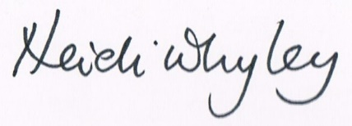
Heidi Whyley
Executive Head Teacher

