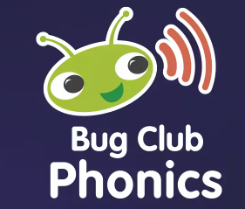
Reading and Phonics at Airmyn

Phonics
In Airmyn Park Primary School, we use the DfE validated synthetic phonics scheme ‘Pearson Bug Club’ to teach children to read and write. A graduated approach is used, and children begin phonics as soon as they enter Reception class through to the end of Year 1.
Phonics is taught daily through a systematic approach, and discreet daily sessions that last approximately 20 minutes. Children apply their new skills when reading books from the Phonics Bug scheme which match the letters and sounds that they have been learning.
Children begin by developing an awareness of sounds through stories, rhymes and games. They quickly move on to learn the links between individual letters and their sounds, and finally how to use the letter sounds for reading and spelling. There are 44 sounds in the English language, which we put together to form words.
Teachers regularly assess children’s progress to check where they are and what they need to learn next. Children are grouped according to their needs, with additional catch-up interventions for those that need extra consolidation. Sometimes children will continue to take part in Phonics sessions above Year 1 if they continue to have gaps in their learning.
From Year 2 onwards, there is much more focus on spelling and children using their phonics knowledge to write a wide range of words. Children are taught to spell words as set out in the national Curriculum for each year group.

Reading
Through the phonics-based approach used in Reception class and Year 1, children are introduced to reading. They learn to decode books that are closely matched to the letters and sounds they are currently learning. They practise these skills through guided reading and individual reading sessions.
Children are encouraged to read at home on a daily basis. Children keep the same book for the week to allow them to apply their skills to decode the text. They then keep the same book to allow them the opportunity to practise reading for fluency. A reading record book is used as a communication tool between parents and teachers. Children are rewarded for their commitment to regular reading.
Children are also provided with log in details for Bug Club online reading resource. Here children can practise phonics through appealing games and activities. They also have access to a wide range of additional books, arranged by difficulty using the coloured book band system that teachers allocate based on a child’s current stage of learning.
When children move beyond Phase 5 phonics and a predominantly phonics approach to reading, then children are taught a broader range of reading skills to develop their understanding of the texts they read. Books are grouped by the coloured book band system and pupils are directed towards the appropriate band for their reading level. Children continue to log their home and school reading in their Reading Record book. Regular reading continues to be encouraged. As well as books being sent home, children continue to have access to the wide range of books online on Bug Club.
What is Bug Club? – All you need to know about phonics
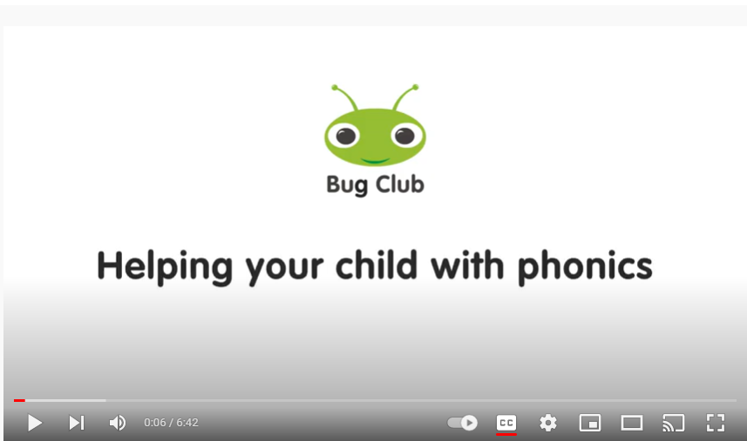
https://youtu.be/0dCRWLLNXPo

Overview of Bug Club Phonics for Parents & Carers
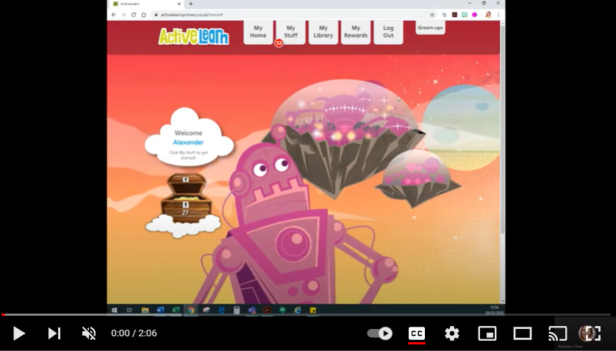
https://youtu.be/MP38k4Vwqu4

Supporting your child with reading
Although your child will be taught to read at school, you can have a huge impact on their reading journey by continuing their practice at home.
There are two types of reading book that your child may bring home:
A reading practice book - This will be at the correct phonic stage for your child. They should be able to read this fluently and independently by the end of the week.
Sharing or reading for pleasure book - Your child should be able to read this on their own. This book is for you both to read and enjoy together, and to support your child to improve their fluency.

Reading practice book
This book has been carefully matched to your child’s current reading level. If your child is reading it with little help, please don’t worry that it’s too easy – your child needs to develop fluency and confidence in reading.
Listen to them read the book. Remember to give them lots of praise – celebrate their success! Support your child to sound out each word and blend the words together. After they have finished, talk about the book together.

Sharing book
In order to encourage your child to become a lifelong reader, it is important that they learn to read for pleasure. Read it to or with them. Discuss the pictures, enjoy the story, predict what might happen next, use different voices for the characters, explore the facts in a non-fiction book. The main thing is that you have fun!

