8th April 2022

Dear Parents and Carers,

I am writing to wish you all Happy Easter!

As you know I leave Airmyn today after 12 fabulous years of some of the happiest years of my life.

It has been a privilege to lead a school with a team of conscientious staff and governors, amazing parents and wonderful children. The way we have collectively supported each other in our school community has been remarkable. We have had much to celebrate over the years forming all those unique happy memories and yet during tough times we have listened, supported and learnt from each other.

Airmyn Park Primary School is a special place, I am proud to say I was the Head Teacher.

Thank you for everything and for all your messages and gifts, I have had the best send-off imaginable.

Best Wishes,

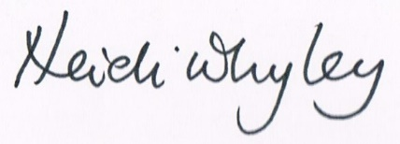
Heidi Whyley
Executive Head Teacher

